Module 1: Managing the Company to Meet Stakeholder Needs 1
Lesson 2: Insurance Company Management 2
Learning Objectives 2
Planning and Organizing in an Insurance Company 3
Organizational Concepts and Directing 13
Managerial Roles 19
Functional Organization 23

Module 1: Managing the Company to Meet Stakeholder Needs
An insurer’s overall direction is determined by its executives, with guidance from the board of directors. In this module, we explore how an insurer is organized and managed to balance the needs of a diverse set of stakeholder groups, and how an insurer manages the risk it must take in order to earn a return.
In this module, you’ll learn about
- How an insurer’s board and executives manage the company ethically to meet the needs of various stakeholders
- The ways an insurer can be organized for success
- How an insurer manages the various risks it faces to earn an appropriate return

Lesson 2: Insurance Company Management
What is management? It is generally described as consisting of four functions. Companies differ in how they approach the four functions of management. Learn about the different ways to organize and run an insurance company.

Learning Objectives

- Describe the four functions of management.
- Recognize typical functional areas for insurance operations, and classify units as line or support functions.
- Describe organizational concepts such as accountability, authority, chain of command, delegation, division of labor, and responsibility.
- Characterize the distinct roles of executives, middle managers, and supervisors.
- Describe how financial services companies use function, product, territory, customer, and distribution channel to structure their organization.

Planning and Organizing in an Insurance Company
Learning Objectives
Describe the four functions of management.
Recognize typical functional areas for insurance operations, and classify units as line or support units.
Start
Every company needs to define who's in charge and who performs what tasks. An organizational structure sets these rules and focuses different individuals on one set of goals. But how do these rules apply to Forthright…or to any company for that matter? It's easy to see the daily contributions of employees like Todd and Rey, but how do leaders like the CEO and President contribute?
Leaders have vast responsibility. Most managers have jam packed schedules from the time they walk into the office until the time they leave. The functions of management are important to company operations. After all, management shapes an organization's vision. This involves planning for the future, organizing personnel, directing work activity, and delegating duties.
In this lesson, we'll explore how different management functions help an organization run smoothly.
One approach to understanding management is to consider the four functions of management:
- PLANNING for desired outcomes
- ORGANIZING tasks, employees, and other resources
- DIRECTING employees and other resources
- CONTROLLING work processes to ensure that actual results correspond to desired results
We'll start with planning.
Planning, Strategy, and Tactics
We all plan for the future and set goals, but not in the same elaborate way as large financial companies. A goal (A desired future outcome. Also called an objective) is a desired future outcome.
Planning (The process of preparing for the future by establishing appropriate goals and formulating strategies and activities for achieving those goals.) consists of identifying goals, and also the strategies and tactics the company will use to achieve those goals.
- Strategies—long-term, high-level plans for achieving goals.
- Tactics—activities to support strategies.
But who sets strategy and who sets tactics?
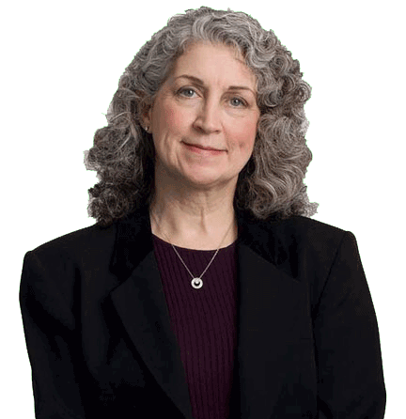
I set strategy. I'm an executive. To set strategy, executives consider the company's goals, resources, capabilities, and circumstances.
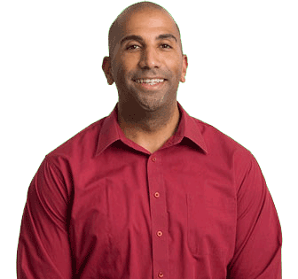
Tactics are my business. I'm a middle manager. Tactics are the specific tasks and activities employees will perform to support the company's strategies and achieve its goals.
Organizing
Organizing (The management function of establishing authority, responsibility, and accountability for accomplishing various company activities, including assembling people and other company resources.) means defining a structure for an organization to enable it to meet its goals. Companies do this by setting up specialized organizational units to perform work activities.
A distinct type of work is often called a function (A distinct type of work or an aspect of operations or management that requires specialized knowledge or technical skill.). So, when organized so that each unit performs a distinct type of work, organizational units are often referred to as functional areas.
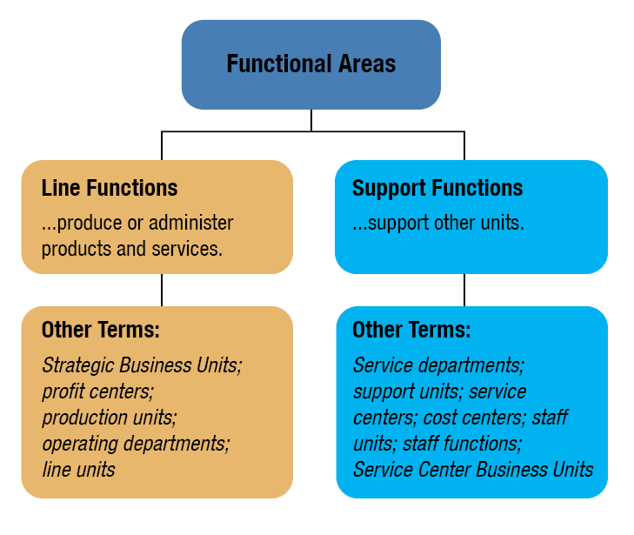
The types of work done by the different functional areas are classified as line functions (A department or other organizational unit that produces or administers products or services.) or support functions (A department or other organizational unit that provides support services to line functions or to other support functions but does not produce or administer products. Also called a staff function.).
Forthright has a major division for each line function and structures work units according to the work they perform. Classification of units as line or support functions—and reporting relationships between units—varies by company. Notably, Investment and Actuarial may be classified as line or support functions.
Line Functions in Insurance Companies
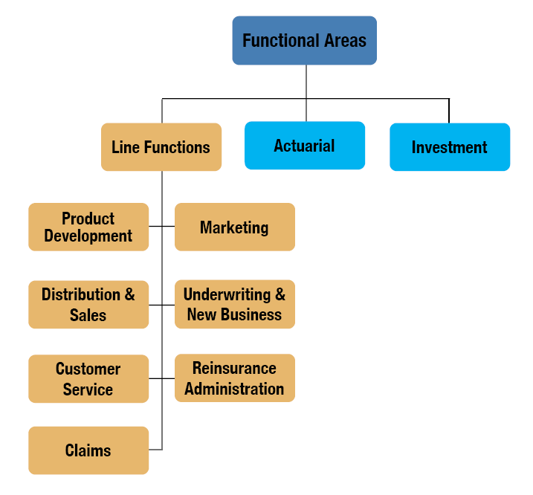
Use the right arrows below to learn about the line functions each work unit performs.

Product Development
Takes new products from concept to launch
Distribution and Sales
Oversees or performs the company's activities for making products available for sale

Customer Service
Assists customers and financial professionals by providing information, processing policy changes, administering financial transactions, maintaining records, and in other ways
Claims
Evaluates, processes, and pays claims for contractual benefits
Marketing
Defines who the company's customers are, what type of products it should offer, and how it should bring its customers and products together
Underwriting and New Business
Analyzes the risk presented by insurance applicants to assign an appropriate premium rate classification; issues policies
Reinsurance Administration
Manages the insurance company's relations with reinsurance providers and files reinsurance claims
Actuarial
Performs numerous activities to ensure that the company conducts its operations on a financially sound basis
Investment Management
Manages the company's investable assets according to company guidelines

Support Functions in Insurance Companies
Read below to learn about the support functions each work unit performs.

Accounting and Financial Reporting
Maintains the financial records of the company's businesses, prepares reports on the company's financial condition, and files required financial statements with regulators
Corporate Communications
Presents a consistent public image and message in all communications on behalf of the company
Finance
Monitors the company's overall financial strength and performance and acquires or uses funds (capital) to help the company accomplish its strategic goals
Information Technology
Develops and maintains computer systems and oversees information management

Risk Management
Coordinates the management of risk throughout the organization
Audit
Performs examinations or reviews to verify the accuracy of procedures or records
Legal and Compliance
Represents the company in all legal matters and ensures that the company's operations comply with all applicable laws and regulations everywhere the company operates
Human Resources
Manages employee hiring, training, development, evaluation, compensation, benefit administration, and terminations
Treasury
Manages cash and near-cash assets


- Thompson considers the company's goals, resources, capabilities, and circumstances to develop long-term, high-level plans. Thompson is most likely
- An executive
- A middle manager
An executive
Thompson is most likely an executive. Executives set strategy. Middle managers focus on tactics, which are the activities that support the overall strategy.

- Sal helps maintain financial records, prepare reports on the company's financial condition, and file required financial statements. Sal most likely works in which functional area?
- Accounting and Financial Reporting
- Audit
- Risk Management
- Legal and Compliance

Accounting and Financial Reporting
Accounting and Financial Reporting is the functional area that maintains financial records, prepares reports on the company's financial condition, and files required financial statements.

- Rodney works in an area that comes up with product ideas and then takes those ideas all the way through creation and launch. Rodney probably works in which functional area?
- Actuarial
- Underwriting and New Business
- Marketing
- Product Development

Product Development
Product Development is the functional area that takes new products from concept to launch.
- Which of the following are line functions? Choose all that apply.

- Product Development
- Marketing
- Corporate Communications
- Treasury
- Customer Service
- Underwriting and New Business
- Audit
- Accounting and Financial Reporting

Product Development
Marketing
Customer Service
Underwriting and New Business
Major line functions—such as Product Development, Marketing, Customer Service, and Underwriting and New Business—produce and administer products. Support functions support each other and the line functions.

Organizational Concepts and Directing
Learning Objective
Describe organizational concepts such as accountability, authority, chain of command, delegation, division of labor, and responsibility.
Forthright uses organizational structure to
- Define employees' primary duties and formal rights to direct the company's resources by specifying authority (The right to direct resources, including people.), responsibility (An assigned duty or task.), and accountability (The duty to answer for one's own actions.)
- Define divisions, departments, and job positions
An organization chart (A visual display of the lines of authority and responsibility within a company. )—also known as an org chart—is a visual display of the lines of authority and responsibility within a company.
Here's a mystery: Why is the classic org chart shaped like a pyramid—narrow at the top and wide at the bottom?
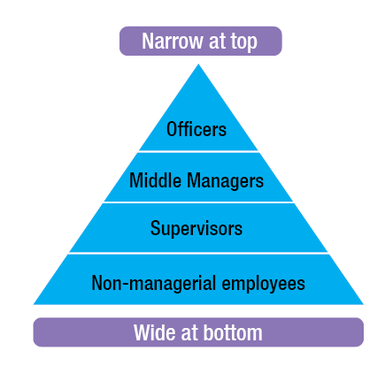
An org chart illustrates how authority flows from top management down to non-managerial employees. Typically, a company has more non-managerial employees than management employees, which makes the org chart wider at the bottom than at the top.
Directing
Directing (The management function of ensuring that employees perform the appropriate activities in the appropriate fashion to achieve company objectives.) involves ensuring that employees perform the right activities in the right way. Managerial activities of directing include
- Leading
- Motivating
- Supervising
- Communicating
- Facilitating
Chain of Command
In a pyramid-shaped organization, authority starts at the top with one person or a very few people and flows down through a chain of command (A hierarchy of authority in an organization, starting at the top with one person or a very few people and distributed downward from the higher levels to the lower levels. Also known as hierarchy; hierarchy of authority.) to ever-larger numbers of people.
Different companies take different approaches to chains of command. In vertical (An organization with a long chain of command and a narrow span of control.) organizations, the chain of command is long, and the span of control (The number of people or functions over which an employee has authority. )—that is, the number of people or functions over which an employee has authority—is narrow.
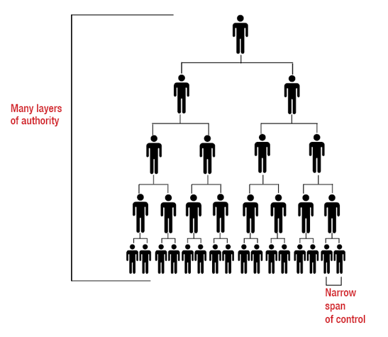
Click or touch in the boxes below to learn about potential benefits and drawbacks of a vertical organizational structure.

Vertical Organization Benefits
Benefits often attributed to vertical organizations include
- Well-defined roles
- Smooth processes
- Easy supervision

Vertical Organization Drawbacks
Vertical organizations sometimes face criticism for the following perceived drawbacks:
- Decisions must move through multiple rungs
- Open communication is less likely, so silos (Operational unit that operates in isolation from other operating units, not understanding how their jobs relate to other operational units or how corporate goals relate to their jobs.) are more likely
- Employees may feel discouraged from sharing creative solutions to problems

In flat organizations (An organization with a short chain of command and a wide span of control. Also called a horizontal organization.) (also called horizontal organizations), the chain of command is short, and the span of control is wide.
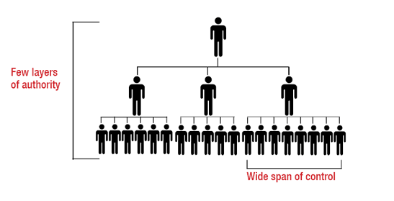
Click or touch in the boxes below to learn about potential benefits and drawbacks of a flat organizational structure.

Flat Organization Benefits
Flat organizations are often said to have the following advantages:
- Limited bureaucracy, which leads to faster decision-making
- Open communication
- Cross-functional teamwork

Flat Organization Drawbacks
Perceived disadvantages of flat organization include
- Undefined roles
- Unclear processes
- Difficulty holding employees accountable for results
In addition, a flat structure isn't always practical for large companies.

Companies' chains of command are based on their business needs and company culture, with many operating somewhere between vertical and flat.
The nature of an organization's chain of command determines how delegation (The process of assigning responsibility and authority to another employee.) and division of labor (The process of dividing large tasks into smaller functional components.) are handled in that organization.
- Delegation is assigning responsibility and authority to other employees—generally to employees lower in the chain of command.
- Division of labor is dividing large tasks into smaller components that can be assigned to different employees.

True or false?

- Authority refers to each employee's duty to answer for his own actions.
- True
- False
False
Authority refers to the right to direct resources, including people. Accountability refers to each employee's duty to answer for his own actions.
- Derek works for a small company as a software developer. He and eight other software developers report to Liam, who is the director of product. Liam reports to the head of the company. Derek works in a company with a
- Vertical organizational structure
- Flat organizational structure
Flat organizational structure
Derek works for a company with a flat organizational structure. The company has a relatively short chain of command and Liam has a relatively wide span of control.

- Delegation refers to which of the following concepts?
- The process of dividing large tasks into smaller functional components
- The hierarchy of authority in an organization
- The process of assigning responsibility and authority to another employee

The process of assigning responsibility and authority to another employee
The process of assigning responsibility and authority to another employee is delegation.

Managerial Roles
Learning Objective
Characterize the distinct roles of executives, middle managers, and supervisors.
Now that we have introduced the functions of management, let's discuss the different levels of management. A typical organization's management consists of executives, middle managers, and supervisors.
Each level of management serves a unique purpose. Any manager at any level will normally wear more than one hat and perform more than just one function. Let's look at the differences in the jobs of these managers.
Executive Officers
The management domain of executives is sometimes called strategic management (The top level of management.)
Executives (also known as officers, or senior-level managers) perform strategic planning (Setting long-term corporate goals and the broad, overall courses of action to achieve these goals. )—setting major long-term corporate goals and broad approaches to achieve them.
A company's executives and officers are the chief executive officer, president, other chief officers, vice presidents, and any other individuals appointed as officers by the board of directors.
Common Executive Positions

Companies can have any number of executive titles depending on their business needs, but most companies have about five or fewer. Some common executive positions include the ones below. Click or touch the arrows to see them all.

Chief Operating Officer (COO)
The executive in charge of all day-to-day company operations

Chief Financial Officer (CFO)
The executive in charge of financial operations

Chief Technology Officer (CTO)
The executive in charge of the company's external technology strategy

Chief Information Officer
The executive in charge of the internal use of information and technology
Chief Marketing Officer
The executive in charge of marketing and communications to customers, clients, and/or partners
General Counsel
The attorney who heads the legal and compliance functions

Some officer positions—for example, Appointed Actuary or Certifying Compliance Officer—are required by regulation or statute.
Middle Managers
Middle managers supervise other managers and report to other managers. Middle management determines how to accomplish the specific tasks for carrying out the organization's strategic plans.
Middle management performs operational planning (Creating plans for day-to-day operations designed to support the organization's strategic plans. Also known as tactical planning.) (also known as tactical planning)—translating strategic-level plans into plans for day-to-day tactical operations within their units.
Supervisors
Supervisors (also known as first-level managers) directly supervise non-management employees and report to middle management employees. Supervisors manage the smallest units of the organization and implement tactical plans.
Supervisors practice operational (tactical) management.
Listen as an expert explains the difference between strategic and operational management.

True or false?

- Operational planning consists of setting long-term corporate goals and the broad courses of action for achieving them.
- True
- False
False
The planning described is strategic planning. Operational planning is translating strategic plans into plans for everyday operations.

- Anya recently received a promotion to claims supervisor. Anya is likely to be responsible for which of the following duties? Choose all that apply.
- Reporting to middle management
- Translating policy and strategic plans into tactical plans
- Directly supervising non-management employees
- Implementing tactical plans
- Setting strategic policy and making strategic plans

Reporting to middle management
Directly supervising non-management employees
Implementing tactical plans
As a supervisor, Anya likely reports to middle management, supervises non-management employees, and implements tactical plans. Anya is probably not responsible for setting strategic policy (executives) or for translating policy and strategic plans into tactical plans (middle management).

Functional Organization
Learning Objective
Describe how financial services companies use function, product, territory, customer, and distribution channel to structure their organization.
Companies can choose from among several types of organizational structures. In fact, most financial services companies combine two or more organizational approaches.
One way to organize a company's operations is organization by functional area—illustrated in this figure.
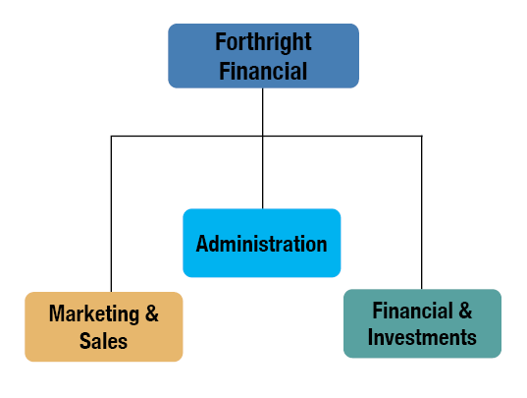
With organization by product (An organizational structure which arranges a company's major divisions according to the company's product lines.), each division focuses on a product line.
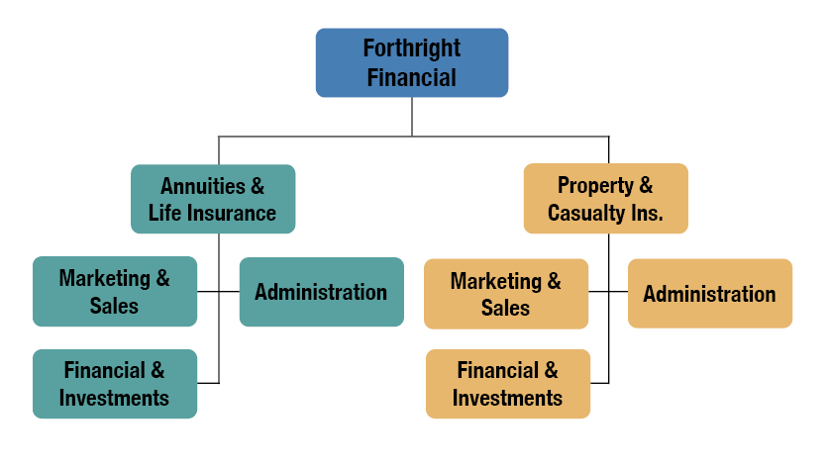
With organization by territory (An organizational structure which arranges a company's major divisions according to the geographic areas in which it operates.), each division serves a certain geographic area.
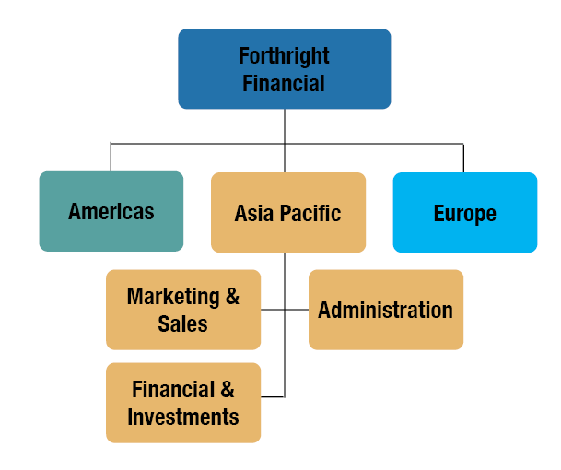
With organization by customer group (An organizational structure which arranges a company's major divisions according to the customer group each unit serves.), each division serves a specified customer group.
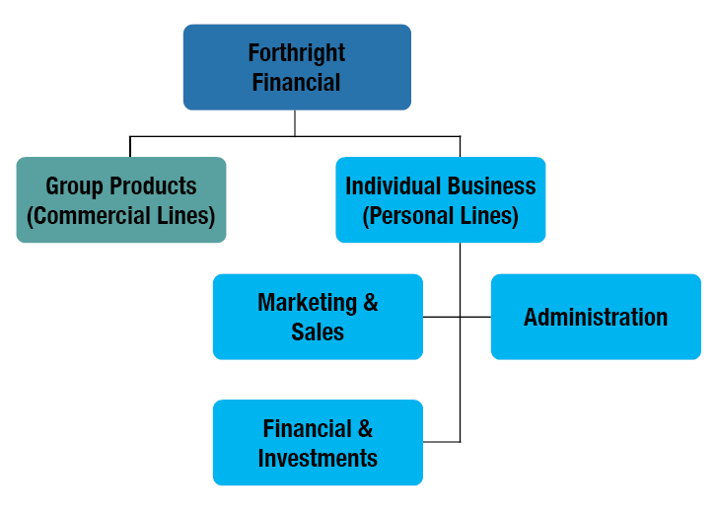
With organization by distribution channel (An organizational structure which arranges a company's major divisions according to the distribution channels that deliver products to customers.), each division works with a given distribution channel.
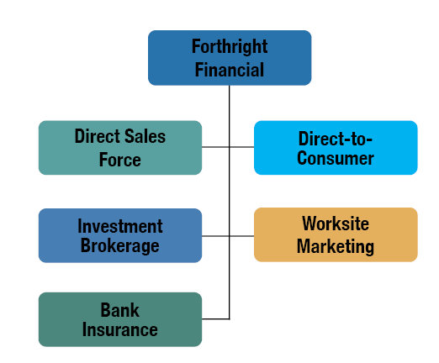


- The following statements are about organizational structure in a typical insurance company. Choose all statements that are true.
- A chief operating officer likely reports to the company's chief executive officer.
- Supervisors typically report directly to middle managers.
- A company that has major divisions for Europe, Asia-Pacific, and the Americas is organized by customer.
- An underwriting unit is classified as a support unit.

A chief operating officer likely reports to the company's chief executive officer.
Supervisors typically report directly to middle managers.

- The Rex Financial Services Company has separate companies for the United States and Canada. Within each of those companies, each has a division for group business and individual business. Then, both the group and the individual business divisions have major departments for each line function. Choose all of the approaches to organizational structure included in this description of Rex.
- Organization by product
- Organization by function
- Organization by territory
- Organization by customer group
- Organization by distribution channel

Organization by function
Organization by territory
Organization by customer group
At the highest level, the company is organized by territory—in this case by country. The division for each country is organized by customer group, and the business unit for each customer group is organized by function.

Suggested Activities
Try these activities to relate the content of this lesson to the real world of your company.
- How is your company organized? Find a copy of your company's organization chart. Can you find your own position on the chart?
- Name some line and support units in your company.
- Determine what organizational structure is used in your company. How about in your division?

Delegation refers to which of the following concepts?

